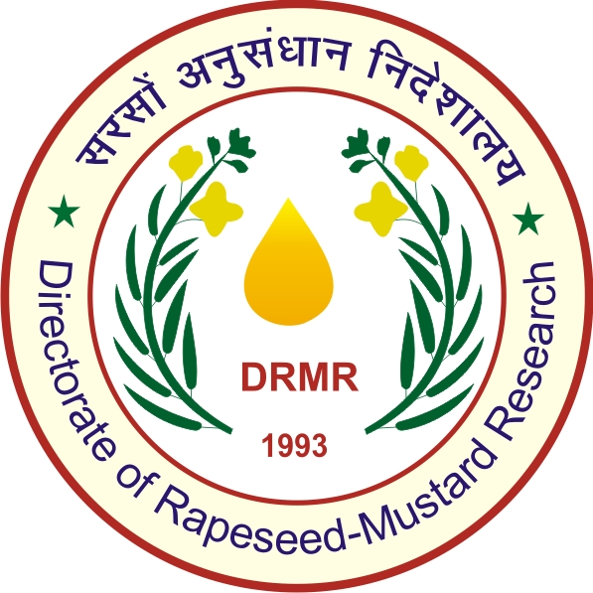
Application for Guesthouse Accommodation
ICAR -Directorate of Rapeseed-Mustard Research
Sewar, Bharatpur (Raj)- 321303

Name:
Aadhaar Number (Compulsory):
Designation:
Official/Residential address:
E-mail:
Tel.No. | Mobile: |  | Office: | Residence:
Purpose of visit | Official |  |  | Private
Category | ICAR/SAU | Retired ICAR/SAU |  | Central/State Government
Duration | From: |  |  | To
Type of accommodation | Single Bed | Double Bed Room |  | VIP Suit
Total No. of persons
Signature with date

Please mail to:
To
The Director
ICAR-DRMR, Bharatpur
Email: director.drmr@gmail.com
Fax: +91-5644-260495

